Agrifood 2025+: the opportunity for Western Australia
This document summarises some of the key pieces of evidence that have informed DAFWA’s understanding of doubling the value of the agrifood sector between 2013 and 2025. Much of this evidence has come from reports commissioned by DAFWA. Click on the hyperlinks to access them.
Some mature industries, such as grains, do not feature strongly in this summary – they have not been the focus of recent DAFWA-commissioned research as their growth opportunity is already well understood and, for example, documented in the WA Grains Industry Strategy 2025+ (GIWA 2015).

We know the opportunity

We know the opportunity for Australia
Australia could more than double the real value of its agricultural exports, driven by growing global food demand, particularly from Asia.
Australia could capture an additional $0.7-1.7 trillion between 2012 and 2050 if targeted actions are taken (ANZ 2012).
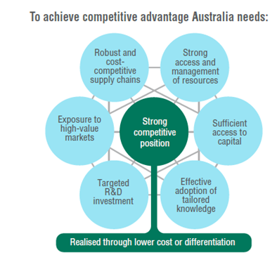
We defined the opportunity for WA
WA industry and government set an aspirational target to double the real value of the sector between 2013 and 2025 (DAFWA 2012 and 2014).
Government commenced the Seizing the Opportunity – Agriculture initiative to investigate and act on the opportunity.
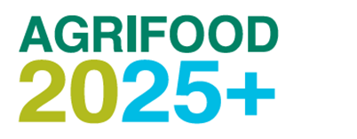

We know doubling is possible by 2025
We can double the real value of the WA agrifood sector.
Government and industry will need to partner more broadly and effectively.
Growth will mainly come from agrifood exports (Coriolis 2015a and DAFWA 2016a).
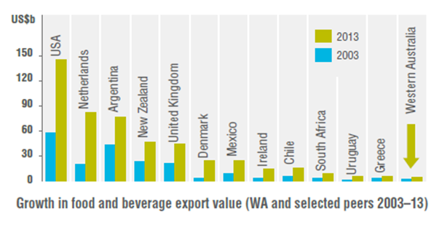

We know it has begun
Many of our peers, and developing countries, have achieved the required growth rates.
We need a 6% real compound annual growth rate to double.
It is starting to happen (Coriolis 2015a and DAFWA 2016a).
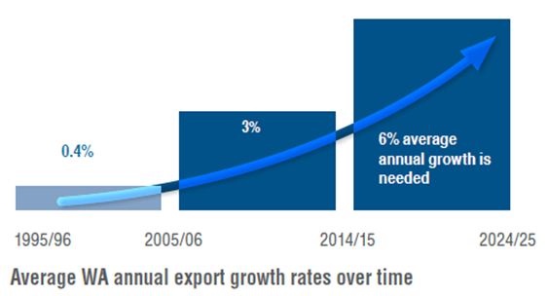

We know what needs to be done to realise the opportunity

We know the Asian market, what it wants and what WA can produce
High growth, high value premium opportunities:
- Wine, beer
- Chocolate
- Processed ham, sausages
- Honey
- Fluid milk
- Yoghurt
- Oranges/mandarins
- Carrots
- Apples
- Avocados
- Prawns
- Rock lobster
- Beef
- Sheep
- Pork
- Virgin olive oil
- Animal pellets
- Rolled oats
(Coriolis 2016a)

We know the potential investors and what they want
Their capital will target:
- developing the sector’s value chains
- transforming WA’s raw materials into consumer-ready goods
- intensifying existing production systems
(Coriolis 2016b).

We know what businesses need for WA to be internationally competitive
- Value chain productivity
- Available resources (land, water, labour, inputs)
- World-class production systems
- Efficient primary wholesale/processing
- Efficient value-added processing
- Accessible markets
(Coriolis 2016c)

We know the value northern WA can add
Opportunities in Asia and the Middle East with high growth potential and a good fit for developing the north:
Good
- Oils: olive, sunflower, mint
- Fresh grapes
- Walnuts
- Dried beans
- Compressed hay
Better
- Cane sugar
- Pistachios
- Lentils
- Soya beans
- Lucerne hay
- Castor oil
Best
- Cassava
- Sesame seeds
- Sorghum
- Almonds
- Cotton
(Coriolis 2015b)

We know what infrastructure the state needs to support this growth
The Seizing the Opportunity Infrastructure Fund is targeting priorities:
- Mobile technology
- Coastal Doppler radars
- Key commodity freight roads
(EY 2016)

Action: strategic direction for DAFWA
DAFWA is:
- the lead government advocate for the sector
- an economic development agency
- underpinned by science, innovation and commercial awareness.
This knowledge will inform:
- DAFWA’s next Strategic Plan: 2017–21
- a long-term strategy for the WA agrifood sector
- how DAFWA measures the government’s impact on the sector.

References
- ANZ, 2012. Greener Pastures: The Global Soft Commodity Opportunity for Australia and New Zealand
- Coriolis, 2015a. Driving for Agrifood Growth – Working Together to Double our Industry by 2025+
- Coriolis, 2015b. Growing the North
- Coriolis, 2016a. Target Market Opportunities in Asia for Western Australian Premium Products
- Coriolis, 2016b. Investment Ready: WA Agribusiness Report
- Coriolis, 2016c. Pathways to Competitiveness
- DAFWA, 2012. Agrifood 2025+ Industry Workshop Report – April 2012
- DAFWA, 2014. Agrifood 2025+ Strategic Plan 2014–17
- DAFWA, 2016a. Western Australian Agriculture and Food: A Global Opportunity
- EY, 2016. Infrastructure Audit: Evaluation of WA’s Agriculture Infrastructure Priorities
- GIWA, 2015. WA Grains Industry Strategy 2025+
Important disclaimer: The Chief Executive Officer of the Department of Agriculture and Food and the State of Western Australia accept no liability whatsoever by reason of negligence or otherwise arising from the use or release of this information or any part of it.
Copyright © Western Australian Agriculture Authority, 2017

