**Sheep Industry Business Innovation**

Comparative analysis of Gross Margins for grain and sheep enterprises in the central and high rainfall regions of the Western Australian wheatbelt

October 2016

Ashley Herbert

Agrarian Management

ashley@agrarian.com.au

0427 007 396

Agrarian Management logo

This study is a Sheep Industry Innovation (SIBI) project commissioned by Mandy Curnow, Program Leader, Sheep Industry Business Innovation, Department of Agriculture & Food WA.

The aim of the study is to “determine the comparative gross margins for a range of enterprises in the two main growing regions of WA”.

The scope of the study is to provide a report on a gross margin analysis of the key cereal and oilseed enterprises (wheat, barley, canola) and three sheep enterprises (wool production with live export turn-off, self -replacing Merino flock with 30% prime lambs and specialist meat production).

This report is in three parts:

1. Historical review of farm benchmarking data from two consulting firms, *Agvise Management Consultants* and *Agrarian Management*, comparing the performance of wheat, barley, canola and sheep enterprises.
2. Projected gross margins of these enterprises based on current expectations of price and production for the 2016 season.
3. Gross margin comparison of four sheep enterprises
   1. Merino flock selling wether hoggets as shippers
   2. Prime lamb enterprise – Merino ewes joined to terminal sire
   3. Merino flock with 30% ewes joined to a terminal sire
   4. Non shearing breed.

**Areas of focus:**

1. Cereal Sheep Zone (CSZ) - The area from Bruce Rock to Tammin.
2. High rainfall Zone (HRZ) - The area west of Katanning and Cranbrook to Kojonup.

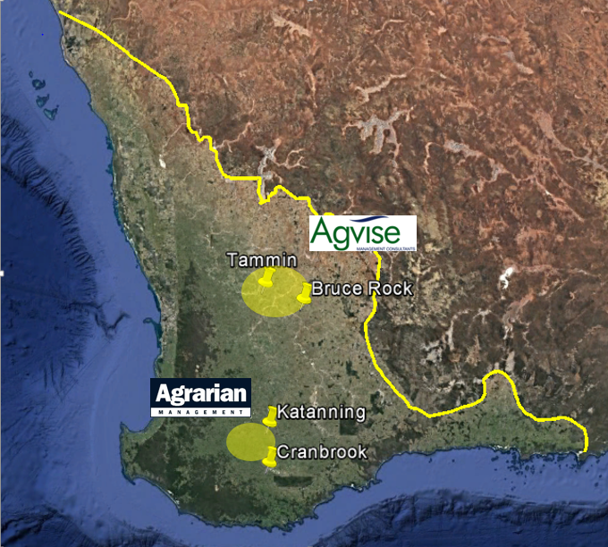

*Figure 1: Locations of area of focus*

**1.0 Historical review**

The information presented is a gross margin analysis of farm benchmark data sourced from two consulting firms:

1. Agvise Management Consultants
2. Agrarian Management

The data has been collected from clients in the two areas indicated in Figure 1 and covers the five year period of 2011 to 2015.

The analysis is based on assessed profit in each season and includes all direct input costs as detailed in Table 1.

|  |  |  |
| --- | --- | --- |
|  | **Crop** | **Sheep** |
| **Income** | Grain income - Farm gate | Wool proceeds (NIB) |
|  | Value of retained grain. | Livestock trading profit |
| **Costs** | Fertiliser | Fertiliser |
|  | Chemical | Shearing, crutching, mulesing |
|  | Seed | Stock requisites |
|  | Contracting | Contractors – eg dipping |
|  | Fuel | Supplementary feed |
|  | R&M | Agistment |
|  | Insurance | Fuel |
|  | Plant replacement | R&M |
|  |  | Plant replacement |

*Table 1: Income and costs included in farm benchmark summary.*

**Cereal Sheep Zone (CSZ)**

**Production**

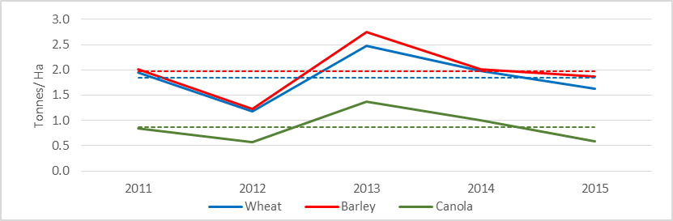

*Figure 2: Crop yields for Cereal Sheep Zone for seasons 2011 to 2015. Average yields for the period –*

*Wheat 1.85t/ha (---), Barley 1.97 t/ha (---), Canola 0.87 t/ha (---).*

Points to note:

1. High level of yield variation between years for all crops.
2. Canola yields are more variable than cereals
3. There is significant variability between individual farms in each year.
4. Average proportion of farm cropped is 74%.

Sheep production summary of the Cereal Sheep Zone for seasons 2011 to 2015

*Table 2: Sheep production summary of the Cereal Sheep Zone for seasons 2011 to 2015.*

Points to note:

1. Stocking rate increase in 2013 was most likely due to increased crop area.
2. Average lambing rate of 84% above the state average.

**Gross Margin**

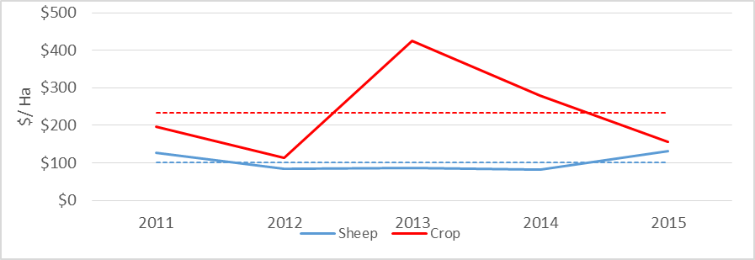

*Figure 3: Cereal Sheep Zone enterprise gross margins. Average GM – Crop $234/ha (---), Sheep $102/ha (---)*

Points to note:

1. Average crop gross margin is significantly higher than sheep
2. Crop gross margin is highly variable between years - $102 - $425/ha.
3. Sheep gross margin is relatively stable between years.
4. In 2 of the 5 years there was little difference between the two enterprises.

Not surprisingly, cropping was clearly more profitable than sheep through this period. However, it needs to be noted that the productivity of the sheep enterprise is grossly constrained by the role pasture plays in the crop rotation. In most cases, pasture is simply an artefact of what germinates in the paddocks not cropped. For the most part, little improvement is done to pastures and fertiliser is not routinely applied.

**High Rain Fall Zone (HRZ)**

**Production**

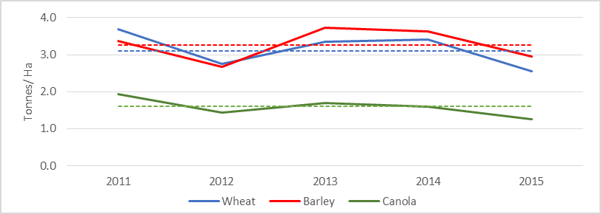

*Figure 4: Crop yield for Cereal Sheep Zone for seasons 2011 to 2015. Average yields for the period –*

*Wheat 3.15t/ha (---), Barley 3.27 t/ha (---), Canola 1.59 t/ha (---).*

Points to note:

1. Considerably less variation between years than in the CSZ.
2. Canola yield variation is similar to wheat and barley.
3. There is significant variability between individual farms in each year.
4. Average proportion of farm cropped 55%.

High rainfall zone sheep enterprise production data for the seasons 2011 to 2015

*Table 3: High rainfall zone sheep enterprise production data for the seasons 2011 – 2015.*

Points to note:

1. The sheep flocks are 100% merino.
2. Majority of lambing occurs in July/ August.
3. Average lambing rate is high at 88%.

The decline in stocking rates from 2012 is possibly in response to increasing crop profitability (Figure 5) and a desire to “simplify” the farm operation. Crop area increased from 47% of farm area in 2011 to 60% in in 2015 in response to the increased returns from crop.

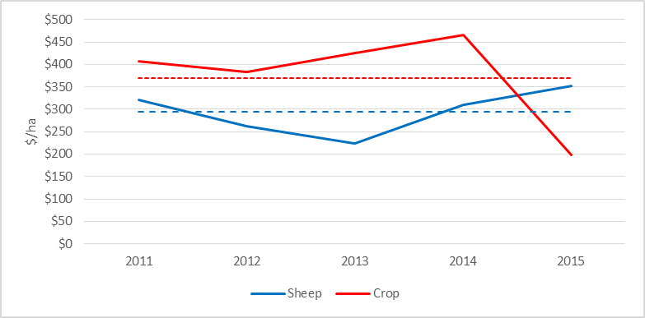

*Figure 5: High rainfall zone enterprise gross margins. Average GM – Crop $370/ha (---), Sheep $295/ha (---)*

Points to note:

1. Considerably less difference between the crop and sheep enterprise gross margins than seen in the CSZ.
2. Sheep gross margin variable.
3. Less difference in the variability between the two enterprises compared to the CSZ.

It is interesting to note the contrasting patterns of crop gross margin between the two data sets. The average crop gross margin in the CSZ was driven by an extremely high level of profitability in one season (2013). While in the HRZ, the average gross margin was driven by the very low profit year of 2015.

**Variation between farms is significant.**

|  |  |
| --- | --- |
| Variation in crop enterprise gross margins | Variation in sheep enterprise gross margins |
| *Figure 6: Variation in crop enterprise gross margins - High rainfall zone* | *Figure 7: Variation in sheep enterprise gross margins - High rainfall zone* |

A danger of looking at group averages is that it fails to highlight the normal level of between farm variation in physical and financial performance. Figures 6 and 7 illustrate the range in farm performance for the crop and sheep enterprise gross margins. The shaded area represents the range in gross margins for each enterprise in each year.

In any one year the between farm variation far exceeds any difference between the enterprises.

The message from this is that the enterprise averages only provide a broad guide as to relative profitability of the farm enterprises. Individual performance is highly variable in each year.

**2.0 Projected Gross Margins for 2016**

A series of gross margins have been calculated for each zone based on expected costs, production and prices to be received for the 2016 season. Details of costs included are outlined in Table 1.

By all accounts, 2016 has been an exceptional season (so far) across most, if not all of the Western Australian agricultural regions. The season has been characterised by good early rain and consistent growing season rainfall. Consequently, crop yield and sheep production expectations are high. While sheep and wool prices have remained strong, cereal grain prices have declined significantly through the season.

Cropping costs are expected to be above average mainly due to significant amounts of additional herbicides applied. Conversely, the early start to the season has greatly reduced the supplementary feed costs of the sheep enterprise.

In view of the comments in the previous section these projections should be viewed as indicative only. They are in no way intended to be a definitive statement on the profitability of each enterprise.

**Cereal Sheep Zone**

These calculations are based as much as possible on actual farm data. The yield expectations are the highest annual averages achieved in the past for the dataset.

|  |  |  |  |  |  |  |  |
| --- | --- | --- | --- | --- | --- | --- | --- |
|  | **Wheat** | **Barley** | **Canola** | **Lupins** |  | **Sheep** |  |
| Yield (T/ha) | 2.5 | 2.8 | 1.3 | 1.3 |  | Stocking rate (dse/ha) | 3.7 |
| Price ($/T FIS) | $250 | $200 | $550 | $350 |  | Wool Price ($/ kg grsy NIB) | $8.50 |
|  |  |  |  |  |  | Wool Cut (kg/hd) | 6.8 |
| Costs ($/ha) | $270 | $274 | $302 | $260 |  | Shippers ($/hd) | $110 |
|  |  |  |  |  |  | CFA Ewe ($/hd) | $65 |
| **Gross Margin ($/ha)** | **$253** | **$167** | **$299** | **$195** |  | **Gross Margin ($/ha)** | **$180** |
|  | **($49/dse)** |

*Table 4: Projected gross margins for the Cereal Sheep Zone based on estimated price and production for 2016.*

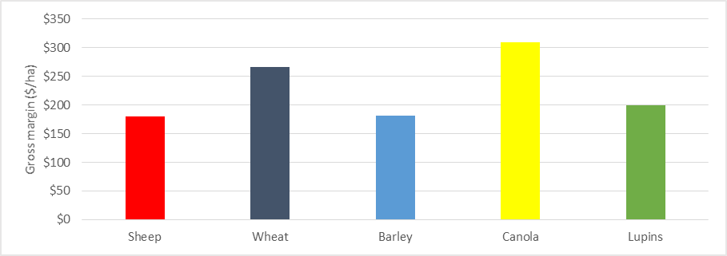

Figure 8:  *Projected gross margins for the Cereal Sheep Zone based on estimated price and production for 2016.*

Despite the low grain price outlook for the coming harvest the projected gross margin is significantly buoyed by the above average yields expected. Provided the yield estimates are achieved the crop enterprise is quite likely to achieve at least an average gross margin.

The gross margin for sheep of $180/ha is significantly above the medium term average of $102/ha which underlines the current strength of the sheep and wool markets.

**High Rainfall Zone**

These calculations are based as much as possible on actual farm data. The yield expectations are the highest annual averages achieved in the past for the dataset.

|  |  |  |  |  |  |  |
| --- | --- | --- | --- | --- | --- | --- |
|  | **Wheat** | **Barley** | **Canola** |  | **Sheep** |  |
| Yield (T/ha) | 3.7 | 3.7 | 1.9 |  | Stocking rate (dse/ha) | 10.5 |
| Price ($/T FIS) | $250 | $200 | $550 |  | Wool Price ($/ kg grsy NIB) | $8.80 |
|  |  |  |  |  | Wool Cut (kg/hd) | 6.0 |
| Costs ($/ha) | $364 | $367 | $373 |  | Shippers ($/hd) | $110 |
|  |  |  |  |  | CFA Ewe ($/hd) | $65 |
| **Gross Margin ($/ha)** | **$407** | **$289** | **$528** |  | **Gross Margin ($/ha)** | **$438** |
|  | **($42/dse)** |

*Table 5: Projected gross margins for the High Rainfall Zone based on estimated price and production for 2016.*

Canola continues to be the most profitable enterprise owing to the combination of high yields and strong pricing.

The high yield expectations are likely to deliver an above average profit for the crop enterprise despite the lower pricing.

The sheep enterprise margin of $438 is approximately 50% above the medium term average of $295/ha. Once again this highlights the extremely profitable conditions the sheep industry is experiencing at the moment.

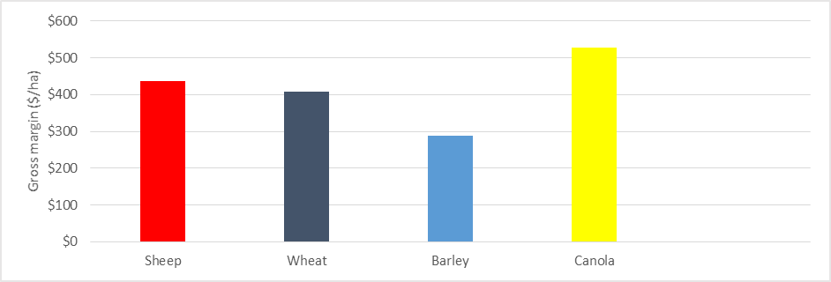

Figure 9:  *Projected gross margins for the High Rainfall Zone based on estimated price and production for 2016.*

It is worth making the point that while the sheep margin is similar to the wheat margin it is at a high figure by historical standards. Given the prices of cereals have declined significantly the overall profitability is held up by the exceptional seasonal conditions.

**3.0 Sheep enterprise comparison.**

In this section the profitability of four sheep enterprises, detailed below, are compared. The base assumptions are taken from the High Rainfall Zone.

|  |  |
| --- | --- |
| **Enterprise** | **Description** |
| 1. Merino | Self- replacing merino flock.  4 age groups of joined ewes 1.5 – 4.5yo.  Selling wethers as shippers off shears at 12 -18mths. |
| 1. Prime lamb | 100% merino ewe flock joined to terminal sire.  5 age groups of joined ewes 1.5 – 5.5yo.  Replacement ewes purchased at 1.5yo.  Lamb sale value equal to shipper price. |
| 1. Merino 30% XB | Self- replacing merino flock with 30% ewes joined to a terminal sire.  Proportional mix of flocks 1 & 2.  Replacement ewes sourced from retained ewe hoggets. |
| 1. Non-shearing | Non-specific non shearing breed.  5 age groups of joined ewes 1.5 – 5.5 yo.  Replacements sourced from retained ewe hoggets.  Lamb sale value equal to shipper price. |

The analysis of Flock Four (Non-shearing) is based on broad general assumptions and is presented here only as a guide to the possible gross margin. Objective data on these types of enterprises is difficult to come by. Results presented here should be viewed in this context.

|  |  |  |  |  |  |
| --- | --- | --- | --- | --- | --- |
|  | **Merino** | **$/dse** |  | **Prime Lamb** | **$/dse** |
| **Stocking rate** | **10.5dse/ha** |  |  | **10.5dse/ha** |  |
| **Wool Income** | $434 |  |  | $353 |  |
| **Livestock Trading Profit** | $270 |  |  | $521 |  |
| **Total Income** | **$704** | **$64** |  | **$874** | **$83** |
|  |  |  |  |  |  |
| **Costs** | $235 | $22 |  | $246 | $23 |
|  |  |  |  |  |  |
| **Gross margin** | **$438** | **$42** |  | **$594** | **$57** |

Table 6: Projected Gross Margin ($/ha) for a merino and prime lamb enterprise based on 2016 price and production assumptions for the High Rainfall Zone.

On a like for like for basis the Prime lamb enterprise is significantly more profitable than the typical merino flock ($438/ha vs $594/ha Table 6). The core assumptions being that stocking rate, lambing rate and sale price are equal.

In reality, this is not always the case. There are often a number of differences between the two enterprises that effectively reduces the difference in profitability.

In general, the prime lamb system is focused on achieving a finished lamb price based on the assumption that price drives profit. To achieve this there are a number of adjustments made to the system to be able to sell lambs at the targeted price. All of which are quite legitimate and understandable.

The first and most significant is the time of lambing. In order to have lambs of a sufficient weight to achieve the target price, lambing needs to be relatively early (eg April/May). As a consequence stocking rate is reduced. This is usually in the order of 20% less than a July time of lambing.

|  |  |  |  |  |
| --- | --- | --- | --- | --- |
|  | **Merino** | **$/dse** | **Prime Lamb** | **$/dse** |
| **Stocking rate** | **10.5dse/ha** |  | **8.4 dse/ha** |  |
| **Wool Income** | $434 |  | $263 |  |
| **Livestock Trading Profit** | $270 |  | $407 |  |
| **Total Income** | **$704** | **$64** | **$670** | **$80** |
|  |  |  |  |  |
| **Costs** | $235 | $22 | $198 | $24 |
|  |  |  |  |  |
| **Gross margin** | **$438** | **$42** | **$472** | **$56** |

Table 7: Projected Gross Margin ($/ha) for a merino and prime lamb enterprise based on 2016 price and production assumptions for the High Rainfall Zone.

In addition, the ewes tend to be kept for longer to reduce the number of replacements ewes required each year. The consequence of this is that losses are slightly higher, average wool cut is slightly lower and the fibre diameter is slightly broader leading to slightly lower fleece values.

Furthermore, costs will be higher if significant amounts of grain is fed to carryover lambs.

All in all, the nett effect of these adjustments is to erode the potential difference in profitability as summarised in Table 7. The prime lamb enterprise is around 10% more profitable.

Following from this is an analysis of the two other sheep enterprises, Flocks Three and Four – Merino flock with 30% ewes joined to a terminal and a non-shearing breed.

|  |  |  |  |  |
| --- | --- | --- | --- | --- |
|  | **Merino** | **Prime lamb** | **Merino 30% XB** | **Non-shearing** |
| Stocking rate (dse/ha) | 10.5 | 8.4 | 10.0 | 8.4 |
| Wool Income | $403 | $263 | $366 | $0 |
| Livestock Trading Profit | $270 | $407 | $310 | $542 |
| **Total Income** | **$673** | **$670** | **$676** | **$542** |
|  |  |  |  |  |
| Costs | $235 | $199 | $224 | $124 |
|  |  |  |  |  |
| **Gross margin** | **$438** | **$472** | **$452** | **$418** |
| ($/dse) | $42 | $56 | $44 | $48 |

Table 8: Projected gross margins ($/ha) for a range of sheep enterprises based on 2016 price and production assumptions for the High Rainfall Zone.

The results presented in Table 8 show little fundamental difference between enterprises.

A possible exception might be the non-shearing flock where a very high lambing rate is required to compensate for the absence of wool income. For the Non-Shearing enterprises to equal the profitability of more conventional sheep enterprises, lambing rates need to be close to 140% (of joined mature ewes).

The general belief is that these breeds readily achieve these high lambing rates, almost as a matter of course. While objective benchmark data isn’t widely available, this doesn’t seem to be the case. While anecdotal evidence suggests such lambing rates are certainly achieved this is only after considerable care and attention to detail has been exercised.

It is important to remember that the between farm variation within each enterprise group is significant. As highlighted in Figure 7, the variation between individuals will eclipse any fundamental difference that may exist between the livestock enterprises.

The performance of management is a far greater profit driver than the actual enterprise *per se*. With appropriate management, each enterprise can perform equally well.

The main conclusion is that there isn’t a demonstrably “most profitable sheep enterprise”. Profitability is highly dependent upon a wide range of variables that are equally variable between individual producers and enterprises.

This also suggests there doesn’t appear to be any real difference between the value of wool and livestock sales to significantly favour one enterprise over the other. The relative value of a particular enterprise to an individual producer is most likely to be determined by the individual’s preference, motivation and management skill.

**Appendix**

|  |  |  |  |  |
| --- | --- | --- | --- | --- |
|  | **Merino** | **Prime lamb** | **Merino 30% XB** | **Non-Shearing** |
| Wool | $403 | $263 | $366 | $0 |
| L'stock Trading Profit | $235 | $407 | $310 | $542 |
| **TOTAL INCOME** | **$673** | **$670** | **$676** | **$542** |
|  |  |  |  |  |
| **COSTS** |  |  |  |  |
| Shearing, crutching mulesing | $100 | $67 | $91 | $0 |
| Stock requisites | $32 | $25 | $30 | $17 |
| Fertiliser | $42 | $33 | $39 | $33 |
| Freight | $13 | $27 | $15 | $22 |
| Supplementary feed | $26 | $27 | $27 | $32 |
| Fuel | $4 | $4 | $4 | $4 |
| R&M | $4 | $4 | $4 | $4 |
| Plant replacement | $15 | $12 | $14 | $12 |
| **TOTAL COSTS** | **$235** | **$199** | **$224** | **$124** |
|  |  |  |  |  |
| **Gross Margin** | **$438** | **$472** | **$452** | **$418** |

Table 9: Projected gross margins ($/ha) for a range of sheep enterprises based on 2016 price and production assumptions for the High Rainfall Zone.

|  |  |  |  |  |
| --- | --- | --- | --- | --- |
|  | **Merino** | **Prime lamb** | **Merino 30% XB** | **Non-Shearing** |
| Wool | $38.35 | $31.30 | $36.79 | $0.00 |
| L'stock Trading Profit | $22.37 | $48.50 | $31.15 | $64.57 |
| **TOTAL INCOME** | **$64.08** | **$79.80** | **$67.95** | **$64.57** |
|  |  |  |  |  |
| **COSTS** |  |  |  |  |
| Shearing, crutching mulesing | $9.52 | $7.93 | $9.17 | $0.00 |
| Stock requisites | $3.00 | $3.00 | $3.00 | $1.98 |
| Fertiliser | $3.96 | $3.96 | $3.96 | $3.96 |
| Freight | $1.22 | $3.19 | $1.52 | $2.65 |
| Supplementary feed | $2.52 | $3.21 | $2.67 | $3.83 |
| Fuel | $0.38 | $0.48 | $0.40 | $0.48 |
| R&M | $0.38 | $0.48 | $0.40 | $0.48 |
| Plant replacement | $1.40 | $1.40 | $1.40 | $1.40 |
| **TOTAL COSTS** | **$22.38** | **$23.64** | **$22.53** | **$14.77** |
|  |  |  |  |  |
| **Gross Margin** | **$41.70** | **$56.16** | **$45.42** | **$49.80** |

Table 10: Projected gross margins ($/dse) for a range of sheep enterprises based on 2016 price and production assumptions for the High Rainfall Zone.

|  |  |  |  |  |
| --- | --- | --- | --- | --- |
|  | **Merino** | **Prime lamb** | **Merino 30% XB** | **Non-Shearing** |
| Open Number (hd) | 7,206 | 6,135 | 6,948 | 6,624 |
| Winter dse | 9,236 | 9,203 | 9,201 | 9,233 |
| Stocking rate (dse/ha) | 10.5 | 8.4 | 10.0 | 8.4 |
| Ewes Joined (hd) | 4,000 | 6,045 | 4,440 | 5140 |
| Lambs (hd) | 3,400 | 5,138 | 3,774 | 6,683 |
| Lamb % | 85% | 85% | 85% | 130% |
|  |  |  |  |  |
| Wool production kg grsy | 40,249 | 35,195 | 39,015 | 0 |
|  |  |  |  |  |
| % Ewes | 56% | 99% | 64% | 78% |
| % dse Ewes | 65% | 99% | 72% | 84% |
|  |  |  |  |  |
| **INCOME** |  |  |  |  |
| % Wool | 60% | 39% | 54% | 0% |
| % L'stock Trading Profit | 40% | 61% | 46% | 100% |
|  |  |  |  |  |
|  |  |  |  |  |
| Purchases (hd) | 12 | 1,386 | 17 | 19 |
| Ewes sold (hd) | 878 | 1,000 | 903 | 879 |
| Lambs sold (hd) | 0 | 4,933 | 1,089 | 5008 |
| Others sold (hd) | 1,922 | 17 | 1,195 | 216 |
| **TOTAL Sales (hd)** | **2,800** | **5,950** | **3,187** | **6,103** |
|  |  |  |  |  |
| Average sale value $/hd | $91 | $101 | $96 | $101 |
|  |  |  |  |  |
| Lambs per ha | 3.9 | 4.7 | 4.1 | 6.1 |
| Wool (kg/ha) | 46 | 32 | 42 | 0 |
| Wool (kg/dse) | 4.4 | 3.8 | 4.2 | 0 |

Table 11: Various indicators for the projected 2016 livestock gross margins for the High Rainfall Zone.