Declared plant surveillance plan:
  - for agricultural weeds in the South West Land Division.

Copies of this publication can be obtained from the DAFWA website.
Authors: Weed surveillance project working groups, Invasive Species program.
Copyright © Western Australian Agriculture Authority, 2015
Except where the Copyright Act otherwise allows, this publication may not be reproduced in whole or in part without the prior permission of the copyright holder. Application for permission should be addressed to the Director, Information and Knowledge Management, Department of Agriculture and Food, Western Australia, Locked Bag 4, Bentley Delivery Centre WA 6983.
Version 2, June 2017

IMPORTANT DISCLAIMER
The Chief Executive Officer of the Department of Agriculture and Food and the State of Western Australia and their employees and agents (collectively and individually referred to below as DAFWA) accept no liability whatsoever, by reason of negligence or otherwise, arising from any use or release of information in, or referred to in, this publication, or any error, inaccuracy or omission in the information.
Although reasonable care is taken to make the information accurate at the time of publication, DAFWA does not make any representations or warranties about its accuracy, reliability, currency, completeness or suitability for any particular purpose. Before using the information, you should carefully evaluate its accuracy, currency, completeness and relevance for your purposes.
The information is not tailored to the circumstances of individual farms or businesses, and does not constitute legal, business, scientific, agricultural or farm management advice. We recommend before making any significant farming, business decisions, you obtain such advice from appropriate professionals who have taken into account your individual circumstances and objectives.

Table of contents
Table of contents 3
Summary 4
Introduction 4
What is surveillance? 4
Weed surveillance targets 5
Declared plants not selected will be in reporting applications 5
High priority surveillance targets 5
Other surveillance targets 6
Where to find weeds? 7
Weed prone sites 7
Weed carrying pathways 7
Where to look for weeds in agricultural, urban and natural landscapes 7
Reporting weed occurrence 11
MyWeedWatcher 11
What to record/collect 12
Mapping weed occurrence 12
Links to surveillance targets 13
Further information 14
References 14

Summary
This weed surveillance plan is intended as a reference to enable participants from the community, industry, biosecurity groups and grower groups to find and report declared plants in Western Australia, especially those weeds identified as surveillance targets. This will enable the early detection of significant new weed incursions and a rapid response to the incursions, thus preventing the intercepted weeds becoming damaging pests in the State.
This surveillance plan was developed for the project, Agricultural weed surveillance in the South West Land Division (SWLD) to protect industry profitability. This is a Boosting Biosecurity Defences project, supported by the State Government’s Royalties for Regions funds.
The surveillance plan describes which declared plants are surveillance targets for this project, where to find declared plants and how to report their occurrence. The plan also has links to further information on each surveillance target. The further information is being updated to including the time of year to look for the weed and where to find it.

Introduction
Western Australia (WA) remains relatively weed free compared to the rest of Australia. About 2740 weed species have been recorded in Australia (Randall, 2007) in comparison to only about 1,250 weed species in WA (Florabase, 2015). In WA, 65 weed species are declared as pests (declared plants) under the Biosecurity and Agriculture Management Act 2007 (BAM Act) and several other species are declared as prohibited organisms (declared plants).
The current set of declared plants includes some that are widespread in the State, others that have a limited distribution in WA, several that are undergoing eradication and others that are not yet present in the State.
The early detection and management of declared plants in Western Australia delivers the greatest economic benefit to the State.
This weed surveillance plan aims to provide a structured approach to weed surveillance the community and other participants, based on identifying:
- the weeds that are surveillance targets,
- where to find weeds
- the most weed-prone sites and
- the most likely weed-carrying pathways
Successful surveillance, based on this approach, will allow the early detection of significant new weed incursions and a rapid response to the incursions, thus preventing the detected weeds becoming damaging pests in this State.

What is surveillance?
Surveillance is keeping a look out for something. In a biosecurity context it is an official process which collects and records data on pest occurrence or absence by survey, monitoring or other procedures (ISPM 5, 2007).

Weed surveillance targets
To be eligible as a biosecurity surveillance target for this project the weed must be:
- a declared pest under the BAM Act: a prohibited organism is a declared pest for the whole of WA.
- an agricultural weed, that has an adverse effect on agricultural production or systems.
- likely to be found in the South West Land Division of WA. This encompasses the wheat belt and includes Perth, Albany, Bunbury, Geraldton and Mandurah
- able to be easily identified by project participants.
Details on the “Declared plant selection process” used to choose surveillance targets can be found through the link: https://agric.wa.gov.au/n/3835.

Declared plants not selected will be in reporting applications
Declared plants neither selected for nor eligible for selection as surveillance targets will have the reporting “app’ developed as part of this project extended to them. However, these weeds will not have extra extension or training material developed for them. It is anticipated that the reporting app will be available in 2016.

High priority surveillance targets
From the perspective of the State’s biosecurity the greatest economic benefit is in finding declared plants before they have a chance to spread throughout the State.
High priority declared plant surveillance targets are those that are on the left side of the invasion curve with prevention and eradication as management options (Figure 1). They are weeds that are thought to be absent from WA or have a small number of localised populations.
The Department of Agriculture and Food, WA (DAFWA) has selected 15 high priority declared plants across these groups to be surveillance targets for the State (Declared plant selection process). These declared plants are:
- Bathust burr (Xanthium spinosum L.).
- bedstraw (Galium tricornutum Dandy).
- branched broomrape (Orobanche ramosa L.).
- creeping knapweed (Rhaponticum repens (L.) Hidalgo).
- gorse (Ulex europaeus L.).
- hoary cress (Lepidium draba L.).
- horsetail (Equisetum hyemale L.).
- karoo thorn acacia (Vachellia karroo (Hayne) Banfi & Galasso).
- kochia (Bassia scoparia (L.) A.J.Scott).
- nodding thistle (Carduus nutans L.).
- perennial thistle (Cirsium arvense (L.) Scop.).
- purple flower devil's claw (Proboscidea louisianica (Mill.) Thell.).
- ragwort (Senecio jacobaea L.).
- skeleton weed (Chondrilla juncea L.).
- wheel cactus (Opuntia robusta H.L.Wendl. ex Pfeiff).
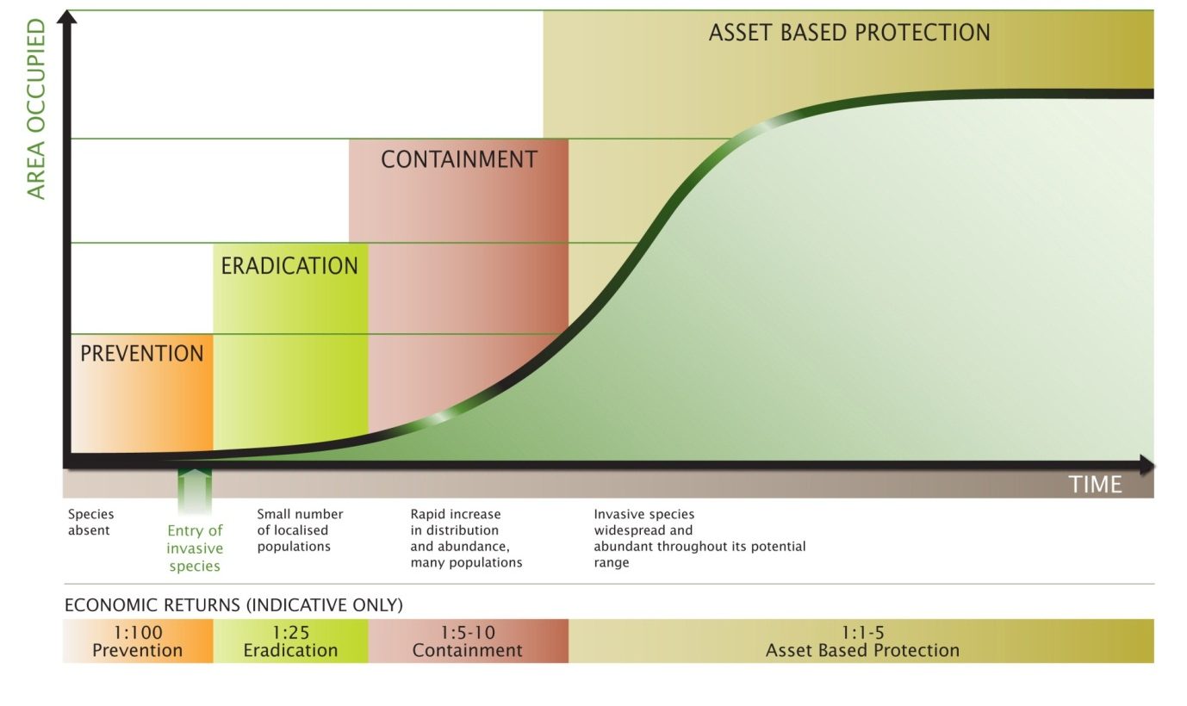
Figure 1 Generalised invasion curve showing management actions (prevention, eradication, containment and asset based protection) appropriate to each invasion stage (absent, small number, rapid increase and widespread) (Department of Environment and Primary Industries, Victoria, 2015).

Other surveillance targets
Most of the weeds on the right side of the invasion curve (Figure 1) are widespread, well-established species that often impact agricultural production and profitability, and might require costly control measures as part of regular agricultural production.
They are important agriculturally, especially to producers seeking profitable production; however, because of their widespread and established nature, they provide relatively low economic return when public funds are invested by government to regulate these species. Consequently, they are of lower priority to publicly funded State/government biosecurity activities than other invasive species that are at the start of the invasion process.
For widespread declared plants at the right side of the invasion curve there is often a high level of industry and community support to manage and control them, sometimes involving a recognized biosecurity group or industry funding scheme to support their management. Industry and community may have a high interest in surveying some of these more widespread declared weeds for their own management programs.
Community, industry, biosecurity groups and grower groups have selected five other declared plant surveillance targets (Declared plant selection process). These declared plants are:
- cotton bush (Gomphocarpus fruticosus (L.) W.T.Aiton).
- arum lily (Zantedeschia aethiopica (L.) Spreng.).
- Paterson’s curse (Echium plantagineum L.).
- Solanum species: silverleaf nightshade and apple of Sodom (Solanum elaeagnifolium Cav. and Solanum linnaeanum Hepper & P.-M.L.Jaeger ).
- doublegee (Emex australis Steinh. and Emex spinosa (L.) Campd.).
If time permits the next two most popular species will be partially included in the project:
- cape tulip (Moraea flaccida (Sweet) Steud. and Moraea miniata Andrews).
- early blackberry (Rubus laudatus A.Berger).

Where to find weeds?
Weeds can be found almost everywhere in WA (Figure 2). The greatest number will generally be found where there is a high level of disturbance created by human activity, or along weed carrying pathways.
Most spread of agricultural weeds results from deliberate or accidental spread by humans, but natural or natural spread (for example, by wind or water) can also occur.

Weed prone sites
Agricultural weeds are generally found at sites disturbed by human activity.
These sites typically receive extra water (for example, the run-off from roads, cropped paddocks and bare soil), light (due to removal of other plants) and nutrients (from fertilizers and nutrient-laden run-off), and are more likely to have weed seeds introduced though agricultural activities.

Weed carrying pathways
Pathways and end-points of weed spread by human activity are obvious areas to target for surveillance; for example, stock-yards, parking places for agricultural vehicles, and sites associated with the dispersal of agricultural waste, waste disposal is associated with rubbish bins, rubbish tips and landfill sites (Figure 2).
Natural spread pathways include searching downwind from a known infestation site (for wind-blown seeds) or downstream (for weed seeds spread by water). Dispersal by birds and other animals is less predictable.

Where to look for weeds in agricultural, urban and natural landscapes
The following lists highlight the main places where weeds are likely to occur in agricultural, urban and natural landscapes, as described in detail in Figure 2.
Weeds should be searched for in and around these sites during general weed surveillance.
These lists are not exhaustive – weeds are adaptable and could occur almost anywhere.
Agricultural production sites
- crops
- pastures
- orchards
- vineyards
- intensive horticulture sites
- forestry plantations
- abandoned or ‘resting’ production sites
Agricultural facilities
- storage areas such as sheds, yards and silos
- machinery yards
- along fence lines and firebreaks
- along tracks and around gateways
- farm dams and watering points
- livestock sale yards
- livestock loading and unloading facilities
- irrigation and drainage channels
- on-farm waste disposal sites
Urban sites
- gardens, parks, recreation reserves, walk trails
- picnic and barbeque sites
- camping sites
- around rubbish bins
- in and around rubbish dumps
- vehicle parking areas
- vehicle wash-down facilities
- old cemeteries
- abandoned homesteads, school sites, mine sites and former town-sites
- derelict or neglected urban land
- along utility easements (e.g. power lines and gas pipelines)
Transport related
- along roads, and railway tracks and easements
- road verges
- roadside ditches
- drainage culverts and run-off areas
- roadside parking bays
- car parks
- flood-ways and fords
- illegally dumped garden waste and other rubbish
In natural landscapes
- along road and tracks
- car parks
- picnic sites
- look-outs
- along walking trails
- recreational fishing spots
- recently burnt areas
- revegetated areas
- under roosting trees chosen by birds
- tree plantations
- along tracks and trails used by native, feral and domestic animals
Water related
- in and along river banks and creeks
- in and around wetlands and swamps
- recently flooded land
- farm dams and irrigation channels
- urban waterbodies and waterways where dumping or aquatic plants (and fish) likely to occur
- downstream of known weed infestations
- on either side of floodways and fords.

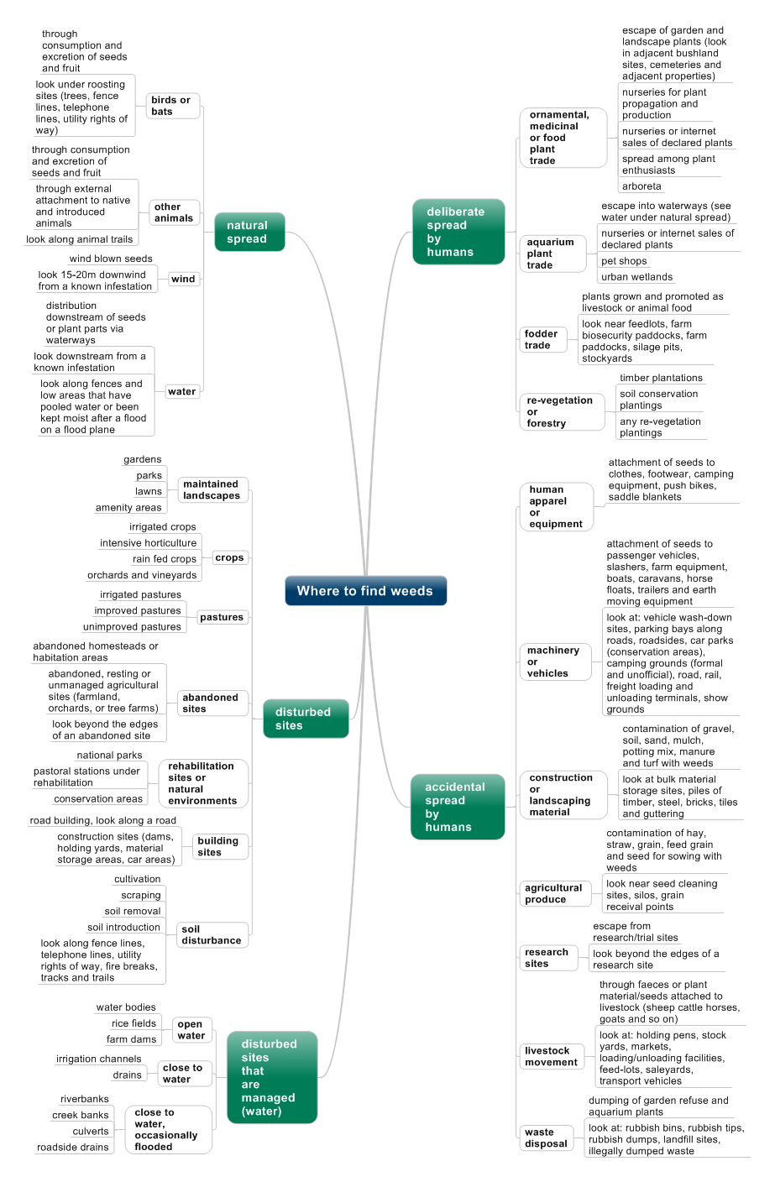
Figure 2: Where to find weeds in WA (modified from (Swarbrick, 1983) and (Sindel, van der Muelen, Coleman, & Reeve, 2008)).

Reporting weed occurrence
All declared plants including those on the surveillance target list should be reported to DAFWA either by calling the Pest and Disease Information Service (PaDIS) on 1800 084 881 or by using the MyWeedWatcher app or web page.

MyWeedWatcher
DAFWA has developed MyWeedWatcher which has been designed to be a user-friendly reporting mechanism for all declared plants. The MyWeedWatcher app can be downloaded free from iTunes App Store or for Android devices from Google Play. Training material on how to use the app is available on the DAFWA website.
MyWeedWatcher is an online database for reporting and mapping weed detections that was released in April 2016. It is available in the form of an interactive website (MyWeedWatcher web) and a mobile device application (MyWeedWatcher mobile). The application is targeted at the South-West Land Division, but can be used anywhere in Western Australia.
The MyWeedWatcher app assists users to record the location of weeds of interest. It produces maps that can be used to make more informed decisions for better management of local weed problems.
MyWeedWatcher contains images and descriptions of over 300 weeds, with more being added, and is supported by detailed information pages on high priority declared weeds.
MyWeedWatcher helps users to identify a weed, record an observation and view observations. The identification guide allows users to quickly search for a weed according to plant characteristics such as flower colour, leaf shape and plant type.
The reporting feature enables users to map weeds, add images and record survey data such as weed density, weed counts, confidence of identification and notes on control activities done. The location of a weed may be recorded using GPS functionality, by searching on a map or by entering GPS coordinates.
MyWeedWatcher Web is an interactive website that provides an online database that allows the public to view maps of reported weeds, download spreadsheets of mapped weeds and report weeds online.
MyWeedWatcher Web makes weed reporting available to people without a mobile device. The web version of MyWeedWatcher makes it easy for users to access and use weed data. Users can generate customised data reports and view or export these as tables or maps. An advantage of the web version over the app is that users can access all MyWeedWatcher records and are not limited to viewing their own observations.
MyWeedWatcher Web provides a versatile online database for community and land managers to make informed decisions on weed management.
Both the MyWeedWatcher app and website allow users to satisfy the reporting of declared pests as required under the Biosecurity and Agriculture Management Act 2007.
Note that the earlier mapping system known as WeedWatcher is no longer available.

What to record/collect
If you are using MyWeedWatcher to report declare plants, the app or website will capture relevant information as well as prompting the user to record other relevant details.
If you are reporting weeds by other means, the following information is the bare minimum required to enable biosecurity groups, industry or DAFWA to plan actions against declared plants.
- Species name (common and/or scientific name).
- Date when observed.
- Location (for example, description or latitude and longitude, or closeness to named localities or geographical features).
- Contact details.
- Collector’s name.
- Collector’s phone number or email.
Optional information that will assist in correct identification of the declared plant includes:
- A photograph of the declared plant.
- A sample of the declared plant (contact DAFWA before sending a sample).

Mapping weed occurrence
Reports made via MyWeedWatch or by other means allow preparation of maps that show the location of declared plants to industry and the community. Maps include data that DAFWA collects as well as data submitted by project participants.
High priority declared plant surveillance targets are treated in a different manner to other weeds because they can be a risk to WA trade and/or might require the landholder to employ new management methods. Because of their importance as weeds, the identity of high priority weeds that are reported via this project is verified by an expert in weed identification before the location is mapped; and the map itself will not show the exact location of the weed. Details of the property boundary, property manager or owner will not be given to the general public.
Other weed surveillance targets (that is, those that are not high priority weeds) will be directly put on a map to advise biosecurity groups, industry and DAFWA of their location and to help determine future management options.

Links to surveillance targets
The following links will take you to information pages on each surveillance target. The information pages will be updated to include data on where to find the weed and a calendar on the best time of year to look for each surveillance target.
- apple of Sodom (Solanum linnaeanum Hepper & P.-M.L.Jaeger)
- arum lily (Zantedeschia aethiopica (L.) Spreng.)
- Bathust burr (Xanthium spinosum L.)
- bedstraw (Galium tricornutum Dandy)
- branched broomrape (Orobanche ramosa L.)
- One leaf cape tulip two leaf cape tulip (Moraea flaccida (Sweet) Steud. and Moraea miniata Andrews)
- cotton bush (Gomphocarpus fruticosus (L.) W.T.Aiton)
- creeping knapweed (Rhaponticum repens (L.) Hidalgo)
- doublegee (Emex australis Steinh. and Emex spinosa (L.) Campd.)
- early blackberry (Rubus laudatus A.Berger)
- gorse (Ulex europaeus L.)
- hoary cress (Lepidium draba L.)
- horsetail (Equisetum hyemale L.)
- karoo thorn acacia (Vachellia karroo (Hayne) Banfi & Galasso)
- kochia (Bassia scoparia (L.) A.J.Scott)
- nodding thistle (Carduus nutans L.)
- Paterson’s curse (Echium plantagineum L.)
- perennial thistle (Cirsium arvense (L.) Scop.)
- purple flower devil's claw (Proboscidea louisianica (Mill.) Thell.)
- ragwort (Senecio jacobaea L.)
- silverleaf nightshade (Solanum elaeagnifolium Cav.)
- skeleton weed (Chondrilla juncea L.)
- wheel cactus (Opuntia robusta H.L.Wendl. ex Pfeiff )

Further information
For further information on declared plants or the Agricultural weed surveillance in the South West to protect industry profitability project please visit the DAFWA website at https://www.agric.wa.gov.au/.

References
Department of Environment and Primary Industries, Victoria. (2015, May 27). Protecting victoria from pest animals and weeds. Retrieved July 23, 2015, from Department of Environment and Primary Industries: http://www.depi.vic.gov.au/agriculture-and-food/pests-diseases-and-weeds/protecting-victoria-from-pest-animals-and-weeds
Florabase. (2015, June 1). Flora statistics. Retrieved July 22, 2015, from Florabase the Western Australian Flora: https://florabase.dpaw.wa.gov.au/statistics/
Hussey, B., Keighery, G., Dodd, J., Lloyd, S., & Cousend, R. (2007). Western Weeds – a Guide to the Weeds of Western Australia. 2nd edition. Perth, 294 pp.: Weeds Society of WA,.
ISPM 5. (2007). ISPM No. 5: Glossary of phytosanitary terms. International Standards for Phytosanitary Measures.
Randall, R. (2007). The introduced flora of Australia and its weed status. Western Australia: CRC for Australian Weed Management Department of Agriculture and Food, 524 pp.
Sindel, B., van der Muelen, A., Coleman, M., & Reeve, I. (2008). Pathway Risk Analysis for weed spread within Australia (UNE61) [final report to Land & Water Australia]. Armidale, 107 pp.: University of New England.
Swarbrick, J. (1983). Working list of weeds of Queensland, the Northern territory, and northern Western Australia. Australian Weeds, 2(4) 156-164.

