Strategy for increasing adoption of Australian Sheep Breeding Values (ASBVs) by commercial producers and stud breeders in Western Australia (WA)

Royalties for Regions
Sheep Industry Business Innovation
Increasing Business and Technical Skills: Genetic Technologies (Activity 3.2)

Meghan Cornelius
Department of Agriculture and Food, Western Australia (DAFWA)
December 2015

Introduction
Genetic improvement is one of the fundamental tools that will enable Australian sheep producers to increase the productivity of their sheep enterprises. The Australian sheep industry has made significant advances in developing and adopting objective measurement and genetic evaluation, however there is still a lot of progress to be made. Funded by Meat and Livestock Australia (MLA) and Australian Wool Innovation (AWI), ‘Sheep Genetics’ has been developed using a comprehensive sheep genetic database and evaluation service, providing commercially relevant information to help sheep producers more effectively select breeding animals for their particular enterprises.
Australian Sheep Breeding Values (ASBVs) are an estimate of an animal’s true breeding value based on pedigree and performance recorded information. They are a necessary tool to determine which ram has the best genes to pass onto their progeny and in the longer term increase the rate of genetic gain not only for individual flocks but for the Western Australian (WA) sheep flock as a whole.
A 2011 report by the Sheep Cooperative Research Centre (CRC) entitled ‘Genetics Training Initiative: Communication and Skills Development Needs Assessment’ concluded that the major barriers to adoption of ASBVs and related technology by the Australian sheep industry is the lack of demand from commercial producers. The lack of demand is driven by a perceived lack of benefit in using ASBVs to select rams. Complexity of the technology and lack of clear market signals for ASBV related traits are also major factors. This is consistent with the barriers to adoption emphasised in a survey carried out in 2011 by Sheep CRC and Department of Agriculture and Food, Western Australia (DAFWA), which were:
- ram buyers are not using ASBVs for buying decisions
- ASBVs are too confusing and too complex to understand and use
- breeders not convinced ASBVs are a useful or accurate tool
- ASBVs are too costly and time consuming to measure.
With these barriers in mind it is obvious that extension efforts need to focus on the ram buyer. We need to demonstrate to them they can add value to their business by adopting ASBVs in their ram selection and purchases, and they need to demand these figures from their ram breeders.
To increase adoption we need to consider the ‘levels of change’ involved and plan activities that work towards them. The levels of change are:
- change in awareness (knowledge)
- change in understanding and skills (persuasion and decision)
- change in practice/behaviour (implementation).
Implementation should be followed with confirmation that the change was for the better and subsequently become an advocate influencing others to change. The figure below (1) demonstrates the adoption decision processes, and activities in relation to this project have been incorporated to show where they fit.
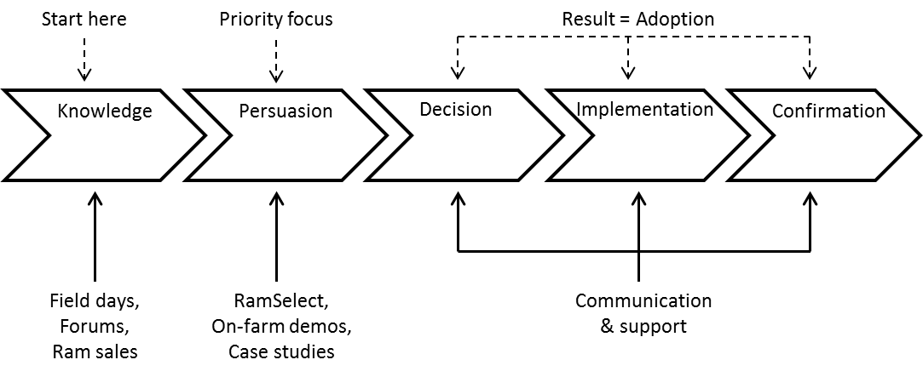
Figure 1 Adoption process
This strategy has a lot of activities that fit into the ‘knowledge’ section which is an important and necessary place to start. The priority focus though is the ‘persuasion’ section which links directly to decision making and adoption.

Situation analysis
In 2014 there were 13 749 rams sold under-hammer from 316 stud flocks (Farm Weekly); 40.8% of these were sold with ASBVs. In 2015 there were 13 904 rams sold under-hammer from 285 stud flocks (Farm Weekly); 43.6% of these had ASBVs (Table 1). This illustrates an increase in the rams sold with ASBVs. While we are seeing a decrease in the number of studs selling rams under-hammer (decrease of 9.8%), the majority (77%) of those are non-ASBV studs.
Table 1 Number of studs using and number of rams sold under-hammer with ASBVs in WA
Year | Measure | ASBVs number | ASBVs % | No ASBVs number | No ASBVs % | Total number
2014 | Rams Sold | 5 616 | 40.8 | 8 133 | 59.2 | 13 749
2014 | Studs | 115 | 36.4 | 201 | 63.6 | 316
2015 | Rams Sold | 6 069 | 43.6 | 7 835 | 56.4 | 13 904
2015 | Studs | 108 | 37.9 | 177 | 62.1 | 285
Difference | Rams Sold | 453 | 8.1 | -298 | -3.7 | 155 (1.1%)
Difference | Studs | -7 | -6.1 | -24 | -11.9 | -31 (-9.8%)
There are currently 163 WA stud flocks that are active members of Sheep Genetics but only 133 (81.6%) of these submitted data in 2015. Of those flocks submitting data, 108 (81.2%) had under-hammer sales, leaving 25 stud flocks with ASBVs selling privately and/or breeding for themselves. This is similar to 2014, when Sheep Genetics had 182 active WA stud flocks with 142 (78%) submitting data and 115 (81%) selling under-hammer.
Between the different breed types, the proportion of rams sold under-hammer include:
- 57.7% Merinos, 37.0% Terminal/Maternal and 5.3% Dohnes (2014)
- 56.9% Merinos, 37.4% Terminal/Maternal and 5.7% Dohnes (2015)
While Merinos are a long way behind the Terminal/Maternal breeds in adoption of ASBVs (Table 2), it is however encouraging to see the increase in the Merinos with ASBVs (16.3%) between 2014 and 2015.
Table 2 Breakdown between breeds of number rams sold under-hammer with and without ASBVs in Western Australia
Year | Breed type | ASBVs number | ASBVs % | No ASBVs number | No ASBVs % | Total number
2014 | Merinos | 1801 | 22.7 | 6140 | 77.3 | 7941
2014 | Terminal/Maternal | 3089 | 60.8 | 1993 | 39.2 | 5082
2015 | Merinos | 2094 | 26.5 | 5817 | 73.5 | 7911
2015 | Terminal/Maternal | 3179 | 61.2 | 2018 | 38.8 | 5197
Difference | Merinos | 293 | 16.3 | -323 | -5.3 | -30
Difference | Terminal/Maternal | 90 | 2.9 | 25 | 1.3 | 115
*Dohnes have not been included in the table as they are all required to have ASBVs as part of the Dohne association requirements. They have their own separate database and analysis.
There is no data collected on the numbers of rams sold or bred privately. However, the WA ewe flock is sitting at approximately eight million ewes therefore the number of rams required each year would be approximately 16 000 (calculated with rams used at 2%). We could therefore assume that approximately 2100 (~13%) rams are sold or bred privately, with the majority of rams being bought under-hammer.

Objectives
DAFWA’s strategic plan aims to enable the WA sheep industry to double its value by 2025. This activity will contribute to DAFWA’s aim in the long term by increasing industry skills and development in the area of genetic technologies.
The objectives of this activity are to:
- increase ram buyers demand of ASBVs from stud breeders
- increase number of rams sold and studs with ASBVs.
The activity aims to achieve a minimum of 60 participants attending RamSelect workshops per annum to assist in the first objective, and aims to increase the number of rams sold with ASBVs in WA to 60% by June 2018. This would double the rate of gain that would have naturally occurred.
These objectives on their own will not increase the rate of genetic improvement of the state flock by themselves. The purpose of these objectives is to ensure that the measures outlined are implemented until the use of ASBVs is commonplace in the industry. Longer term support and encouragement will still be required to ensure breeders are using ASBVs and genetic information to continually make progress in their breeding objectives.

Milestone: develop and implement a strategy to increase the adoption of ASBVs.
This document outlines the strategy to meet the milestone above.

Target audiences
To increase the adoption of ASBVs we need to convince sheep producers and ram breeders of the value of the technology and motivate them to use it. The target audiences for this project are described in the following four sub-sections.

Commercial sheep producers (ram buyers)
There are approximately 5600 commercial sheep producers in WA (Table 4). We aim to increase their knowledge, understanding and skills on ASBVs and educate them on how they can be used to increase the profitability of their own flocks. This target audience is essential in increasing adoption of ASBVs by demanding them from their stud breeders, but they won’t until their confidence and capabilities improve.

Ram breeders that are existing Sheep Genetics members
There are approximately 163 ram breeders that are currently Sheep Genetics members. These breeders have varying levels of experience; some are members for the potential of faster rates of genetic gain and some are only members for ram sale purposes. This target audience needs opportunities to increase their knowledge, learn how to better interpret ASBVs and increase their genetic gain.

Other ram breeders (potential new members of Sheep Genetics)
There are approximately 128 sheep breeders selling rams each year that are not currently members of Sheep Genetics but who are already collecting the data required. They require assistance and encouragement to learn how to measure and interpret ASBVs to understand the extra value they can gain by having them. It is important that new studs joining Sheep Genetics understand and use ASBVs to their full potential and don’t join just for marketing purposes. That can lead to lack of effort and interest in improvement and then dropping off the system.

Livestock agents and sheep consultants
A rough estimate of livestock agents and sheep consultants in the sheep producing regions of WA is approximately 125. We aim to increase their knowledge and understanding of ASBVs and educate them on how producers and breeders can use them to improve their flocks. This target audience can be a source of advice to producers. Consultants can become advocates of the system, and if livestock agents can understand the value of ASBVs then any negativity due to ignorance can be minimised.

Activities to meet objectives
The table (3) below shows the main activities of this adoption strategy, the target audience they apply to and the potential number of people that could be reached. Each activity is discussed in further detail in the following sub-sections.
Table 3 Project activities and potential exposure (per annum) for impact
Purpose/ impact | Activities | Ram buyer | Stud breeder | Stock agents /consultants | Minimum* exposure (people/annum)
Skills development | RamSelect | √ | √ | √ | 60
Skills development | DataSmart | No data | √ | No data | 15
Skills development | RamPower | √ | √ | No data | 10
Skills development | MateSel | No data | √ | No data | 5
Awareness & understanding | Ram Sales | √ | √ | √ | 80
Awareness & understanding | On-farm demonstrations | √ | √ | √ | 50
Awareness & understanding | Sheep field days | √ | √ | √ | 40
Awareness & understanding | Agricultural shows | √ | √ | √ | 40
Awareness & understanding | Conferences/forums | √ | √ | √ | 20
Awareness & understanding | Media | √ | √ | √ | -
No data | Total | No data | No data | No data | 320
*The minimum exposure numbers for the ‘Awareness & understanding’ activities are estimated on the number of contacts and discussions had with producers, breeders and industry professionals at the listed events.

Increase ram buyer demand of ASBVs

RamSelect
The RamSelect program is a full day workshop that educates participants on how to better understand ASBVs and how to successfully utilise them for ram selection decisions. RamSelect was rolled out in 2012 and has run 129 workshops nationally with 2593 participants by December 2015. Western Australia has only had 13 of these workshops with 237 participants. It is a main activity of this strategy to facilitate as many of these workshops as possible around the regions.
The program is proven to be effective in increasing adoption of ASBVs as 98% of participants (nationwide) have indicated they have a better understanding of how to make better use of ASBVs and 87% of participants indicated they would use ASBVs to select rams in the future. The overall impact of the program on the sheep industry was shown in the Sheep CRC 2014 producer survey with the proportion of producers using ASBVs and performance data to select rams having increased from 32% to 42% between 2011 and 2014.
Ensuring delivery of RamSelect workshops to WA producers is a key activity of this strategy. Approximately 60-100 producers should go through RamSelect workshops per annum (based on 6-10 workshops with minimum of 10 participants at each). Theoretically this could translate to an increase of approximately 120-300 rams each year being bought with ASBVs that would not previously have been without participation in RamSelect.
The table (4) below demonstrates the geographic regions where sheep producers and studs with ASBVs are located. Workshops can be targeted to the areas that would have the most coverage, such as the Great Southern, and impact such as Wheatbelt South and Wheatbelt North (low rainfall). Studs with ASBVs are used as the hosts for the workshops, so timing and location of workshops will vary depending on the host. The time of year most suited for running workshops for sheep producers in WA would be March/April and then again in July/August. These months are the best times of year to attract farmers along as they don’t interfere with any cropping enterprise activities.
Another workshop opportunity for producers that incorporates an element of RamSelect is the ‘Bred Well Fed Well’ workshops. Whenever these are being held it would be worth promoting and encouraging producers to attend as it is a great introduction into ASBVs which can lead them into attending RamSelect.
Table 4 Sheep and sheep producer numbers by region (see also Figure 2)
WA regions | Sheep  numbers* | Sheep  producers* | Studs selling rams by auction - total | Studs selling rams by auction with ASBVs | Studs selling rams by auction %
Great Southern | 6 389 637 | 1762 | 96 | 47 | 49%
Wheatbelt South | 2 914 908 | 935 | 79 | 28 | 35%
Wheatbelt North (low rainfall) | 2 352 264 | 1129 | 60 | 14 | 23%
Wheatbelt North (high rainfall) | 1 249 445 | 440 | 12 | 7 | 58%
Mid-West | 1 191 435 | 518 | 18 | 6 | 33%
Esperance regions | 905 522 | 297 | 11 | 5 | 45%
South West/Perth | 336 781 | 588 | 9 | 1 | 11%
*Numbers from DAFWA analysis 2012/13
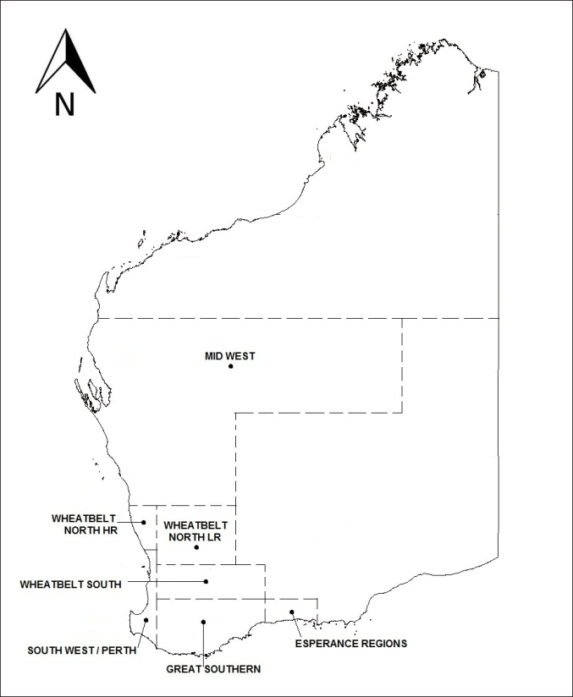
Figure 2 Map of WA sheep regions

RamPower
RamPower is a useful tool developed by Sheep Genetics for ranking animals based on performance measures. This program can be used as an extension tool for commercial producers to create interest in benchmarking performance within a flock. To get results, all that is needed is an animal identification (ID), body weight, fleece weight and fibre diameter. This tool can assist producers with ram and ewe selection, ranking them based on production parameters and sparking their interest in benchmarking animals by performance rather than visual assessment only. We aim to discuss RamPower with producers at field days to create interest and use of the program, and use it for a minimum of five producers each year.

Field days
Attendance at field days, shows, expos, and forums is essential to keep ASBVs topical. It allows for contact and discussions with the target audiences that are yet to be engaged throughout the year. In WA there are four main agricultural shows that can be attended (Wagin Woolorama, Dowerin Field Day, Newdegate Field Day, Mingenew Field Day) as well as multiple field days, expos and forums run by various grower groups and agricultural organisations. The Grower Group Alliance (GGA) advertises all these events on its calendar throughout the year, which is regularly monitored to keep track of what opportunities are coming up.

Ram sales
Being present at ram sales throughout the season to assist ram buyers in understanding the figures is very valuable. At these events it is a great opportunity to set up posters and/or displays to grab attention. To make the most out of being at the sales it would be best to be present at studs’ field days prior to the sale, giving buyers time to absorb the information and come to the sale armed with their new knowledge and any questions.

Media
Media channels are used to keep ASBVs as a current topic and a reminder of how important they are. Available media channels include DAFWA media releases, DAFWA twitter, DAFWA website, newsletters (AgMemo and Ovine Observer), Sheep CRC website, Sheep CRC email updates, and local rural media (e.g. ABC radio, Farm Weekly and Countryman). All RamSelect workshops should be advertised on social media and a media release written either pre/post workshop or both. The DAFWA webpages on genetics and ASBVs will be added to and kept up-to-date and seasonal articles submitted to the Ovine Observer newsletter. Other channels for promotion include the Ramselect.com website/app, sire evaluation sites and case studies, which should also occur once a year.

Increasing number of rams sold and studs with ASBVs

Demonstration sites
On-farm demonstration sites provide a great opportunity to display the value of technology and genetic evaluation; to prove how easy sheep handling and recording measurements can be, opportunities to showcase electronic identification (EID) technology, and all related hardware can be an effective method.
Although this technology is not essential for attaining ASBVs, it can make it easier for those claiming it is time consuming and complex. Cost has also been indicated as a major barrier to adoption and while there are added costs to recording ASBVs it is worth demonstrating that savings of time and labour can be achieved.
Case studies on breeders who have already been using ASBVs and/or EID technology are great demonstrations on the longer term gain and value from the technology. Case studies should be used for promotion and as encouragement to other breeders not currently using the technology. A new case study can be used every year. The 2015 case study was published in the Countryman ram sales magazine and is to be also published in MLA’s Feedback magazine for January/February 2016; while a related video has garnered 531 views to date.

DataSmart
DataSmart workshops offer breeders the opportunity to learn about data management, data quality and software programs for managing data. Managing data can be daunting and confusing for many breeders and these workshops provide the opportunity to overcome any problems, issues and misunderstandings they may be having.
DataSmart workshops, developed by Sheep Genetics, are currently delivered by Debbie Milne from Victoria and funded by the Sheep CRC. It is a great opportunity to have Debbie over for a week each year to run workshops, incorporating the programs Pedigree Master, Stockbook, and/or Koolperform (depending on demand). For workshops to be viable a minimum of five businesses must attend each workshop, and we aim to run two to three workshops in the week.

MateSel & genetic gain
MateSel is a program, developed by Sheep Genetics, for assisting stud breeders that are already members of Sheep Genetics (with pedigree information on most animals) in mate selection and allocation. MateSel helps determine which matings are most likely to increase gain for the selected breeding objective while managing inbreeding.
Training is required to have access to MateSel, resulting in many WA breeders not having access to the program. In this case they can utilise the extension officer to work with them on their breeding programs. It is a good opportunity for network development, relationship building, and improving genetic gain.
Another project being developed by Sheep Genetics (with Sheep CRC, AGBU and New South Wales’ Department of Primary Industries) is the ‘RAMping Up Genetic Gain’ project which aims to work with breeders to increase genetic gain through improved benchmarking, diagnostics and predictive tools. This is a key project to be involved in and is an opportunity to interact with and assist breeders with their breeding programs.
Ultimately these programs, tools and on-property visits allow us to support the Sheep Genetics members to continue their commitment to the program and improve their rate of genetic gain.

RamPower
To target the ram breeders that are not currently members of Sheep Genetics, a potential tool for increasing interest in benchmarking is the ‘RamPower’ tool, which was previously discussed above in sub-section 5.1.2. Increasing interest in benchmarking performance within flock could lead to breeders wanting to be able to compare their animals to other flocks. We aim to discuss RamPower with breeders at field days to create interest and use of the program, and to use it for a minimum of five breeders each year.

Media
Similar media channels for ram breeders as for ram buyers will be used including DAFWA media releases, DAFWA twitter, DAFWA website, DAFWA newsletters, Sheep CRC website, Sheep CRC email updates, Stud Breeders Associations website and newsletters and local rural media (e.g. ABC radio, Farm Weekly and Countryman). Topics for promotion include Datasmart workshops, Ramselect.com website/app, sire evaluation trials and case studies, which should occur at least once a year.

Agents and consultants
Livestock agents and consultants should be encouraged to attend Ramselect workshops as it is the best means of understanding ASBVs.
When Sheep Genetics staff travel to WA for their annual regional forum it would be a great opportunity to organise professional development type days/ presentations to be delivered to agents and consultants by the Sheep Genetics staff.
Being available as a mentor to answer any questions is as important for this audience as it is for breeders and buyers.

Training for extension officer
It is an important part of the role to keep up-to-date with advancements and developments in the area of ASBVs and genetic technologies. This enables the extension officer to be a valuable and current source of information for sheep producers and breeders.
To stay abreast of the changes and developments the most important training opportunity to attend annually is the Sheep CRC & Sheep Genetics Service Provider training. Sheep Genetics and Sheep CRC also hold other training opportunities throughout the year and it is important that the extension officer keeps informed of what might be valuable to attend. These include, but are not limited to, the Sheep Genetics Regional Forums and the Leading Breeder Forum.
Another opportunity being discussed is the development of an ‘extension network group’ for officers in similar roles. The group would consist of extension officers around Australia (and New Zealand) communicating regularly with each other, and with Sheep Genetics staff, to share ideas, experiences and assist each other with common problems. We are all working towards the same goal of increasing adoption of ASBVs.

Monitoring and evaluation
The statistics discussed in the situation analysis (section 2) were gathered from the Farm Weekly paper which reports all under-hammer ram sales every year. Analysis of this data can determine any correlations and trends in regards to price received and use of ASBVs. Positive and significant results can be used as an extension tool showing economic benefits to aid adoption. It also helps monitor how the industry is changing in regards to numbers using ASBVs. Information of which studs are active members with ASBVs comes from Sheep Genetics.
At the ram sales attended, the prices received per animal are recorded and analysed to determine buying trends. Prices are compared to the traits that are available to the buyers. This can show what impact adoption strategies are having as stronger correlations become evident between prices and the main traits associated with production and profit. This allows tracking of any progress and changes in the potential utilisation of ASBVs by buyers. This information is used to see which traits are of most interest to buyers, and also demonstrates which studs have actively educated their clients about the figures. The studs that don’t have strong correlations with prices and ASBVs can be approached as hosts of RamSelect workshops and be used as an example to educate both themselves and their clients.
To monitor and evaluate changes in commercial producers’ ram buying practices, RamSelect participants complete an evaluation form at the end of the workshops rating its usefulness and impact. Data is collected on the impact the workshop has had on increasing understanding of ASBVs and changing ram selection practices. The results of these evaluations can track the proportion of participants that say they will now incorporate ASBVs in future ram selection decisions. Saying they will change however does not always translate into actually making the change, so being available as a mentor and creating opportunities for discussions and answering questions for those having done the course can provide the extra support that might be needed to make the change.
In the future, the 2018 WA Producer Survey once conducted will gauge the reach of ASBV use among the broader population of producers and the 2018 Agribusiness Survey for the boarder population of agents and consultants.

